Handbook
This handbook will provide links to resources that will help you continue down the path of providing more ADST projects. Produced by: Randy Grey, randy.grey@sd71.bc.ca
Construction Foundation website: https://skillsready.ca/ Also check out the projects portal
For a bit of history, you may want to keep checking on the Skills Ready web site, as the Construction Foundation has helped provided millions of dollars in funding for tools to school districts over the last few years.
School District #71 Careers website has lots of current projects and links.
https://careerprograms.comoxvalleyschools.ca/
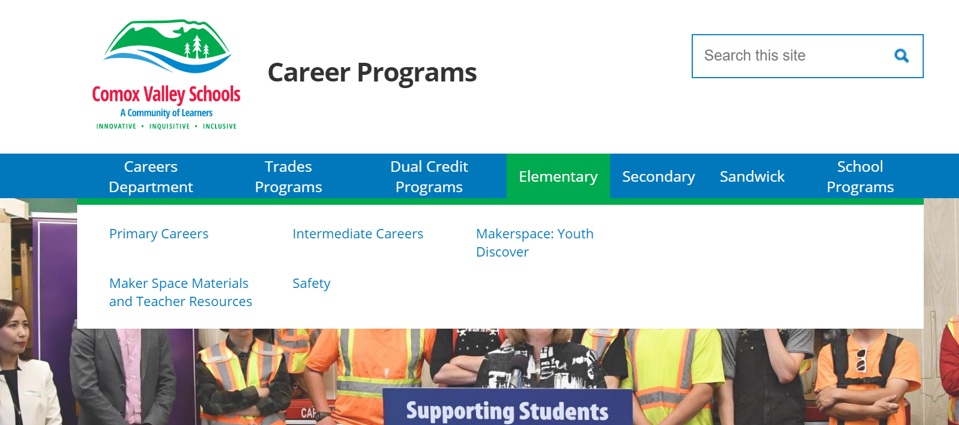
Industry Training Authority (ITA) website: http://youth.itabc.ca/trade-finder/
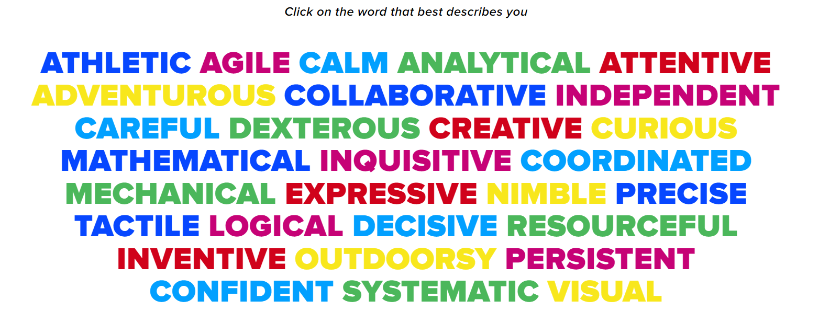
The ITA supplies a lot of funding to most school districts in the province with the hope that more young people will identify that they like to work with their hands and heads and may get into a trade after graduation.

British Columbia Technology Education Association website: www.bctea.org/heads-up-for-safety
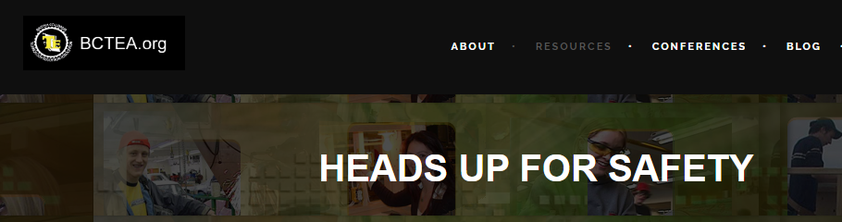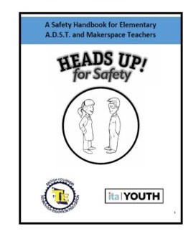
Check out the resources tab for safety procedures and project ideas.

Career Trek: https://www.careertrekbc.ca/
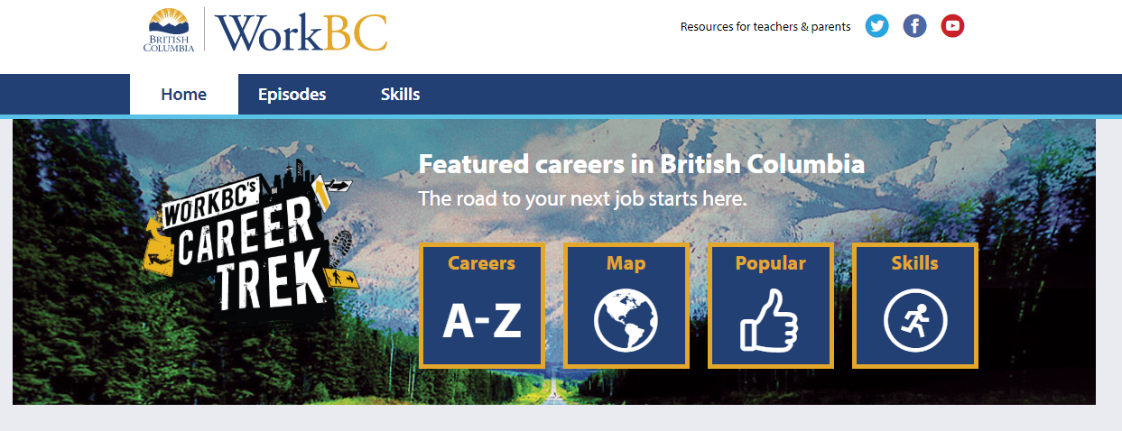
Career Trek has over 100 short videos about different careers in B.C, not just trades.

BC ADST curriculum: curriculum.gov.bc.ca/curriculum/adst
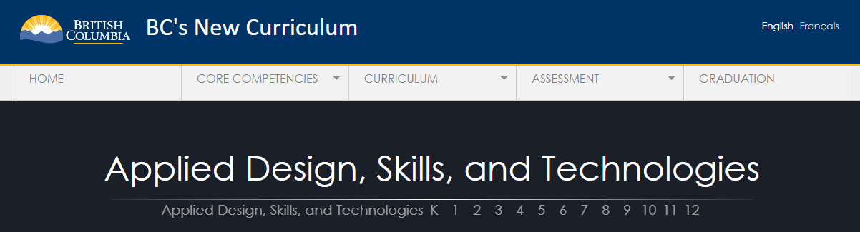

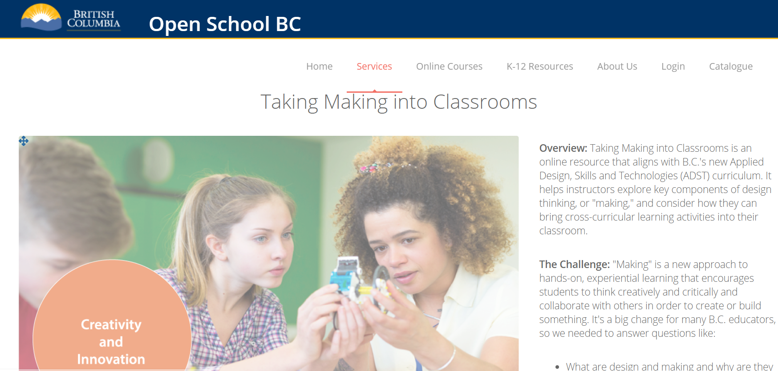

Design thinking and the new ADST curriculum links: mytrainingbc.ca/maker/index.html
